先导知识

参杂
n-type Dopant(掺杂剂)
有自由电子
p-type Dopant(掺杂剂)
有空穴

线性与非线性设备
linear devices properties
• Output signal is proportional to input signal;
• Linear devices obey the superposition principle;
• In AC operation, the input and output signals appear at the same frequency (no frequency conversion).
Nonlinear Devices
Output signal is not a linear function of input signal;
• Nonlinear devices in general do not obey the superposition principle;
• In AC operation, the input and output signals do not appear in the same frequency (frequency conversion).

（这门模电主要将研究非线性设备，二极管，晶体管 diodes, transistors, mixers）

p-n Junction
电流只能由P流向N，这是一个二极管
一块本征硅intrinsic silicon一端为N一端为P，N中的自由电子向P端载流子（空穴）漂移
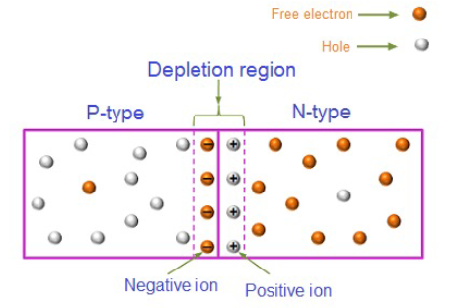

depletion region（耗尽区）阻碍多数载流子（majority carriers.）
barrier potential（势垒）is the potential difference that leads to the electric field across the depletion region.
势垒就是两极间的势能差，外加电场等于这个值后才能流动

偏置电压
Forward Biasing（正向偏置）正极接P负极接N，耗尽层变小
Reverse Biasing（反向偏置）正极接N负极接P，耗尽层变大
（内电场是N指向P，当正偏的时候外电场方向和内电场相反，耗尽层变小，反之亦然）

结型场效应管Junction Field Effect Transistors(JEFT)
类似于电流控制的电阻BJT，电压控制的电阻是FET(我们学习FET)
FET定义
FET is a transistor whose behavior can be controlled by electric fields. Electric fields
are generated by electric potential differences (voltages), so FETs are voltage-controlled devices.

夹断
Pinch-off refers to the condition when VDS is increased to a level that the depletion region completely ”blocks” the conduction channel. The level of VDS that establishes this condition is called the pinch-off voltage;
The pinch-off voltage is also the level of VGS required to completely shut down a JFET
Vp对于N通道是负的，P通道是正的
n-type JFET,s极接地，P型S极接高电平
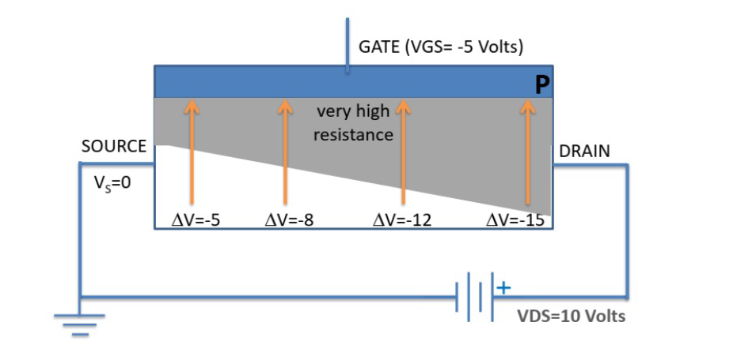

N型材料导电，耗尽层的电阻极大，增大Vds时将会如图所示的渐渐使N型通道夹断
当增大到夹断时理论讲不会有电流流过了，实际上还会有（不考虑通道长度效应时Vds的增大几乎与电阻的增大抵消了）事实上有通道长度效应的话，电阻特性曲线如下所示
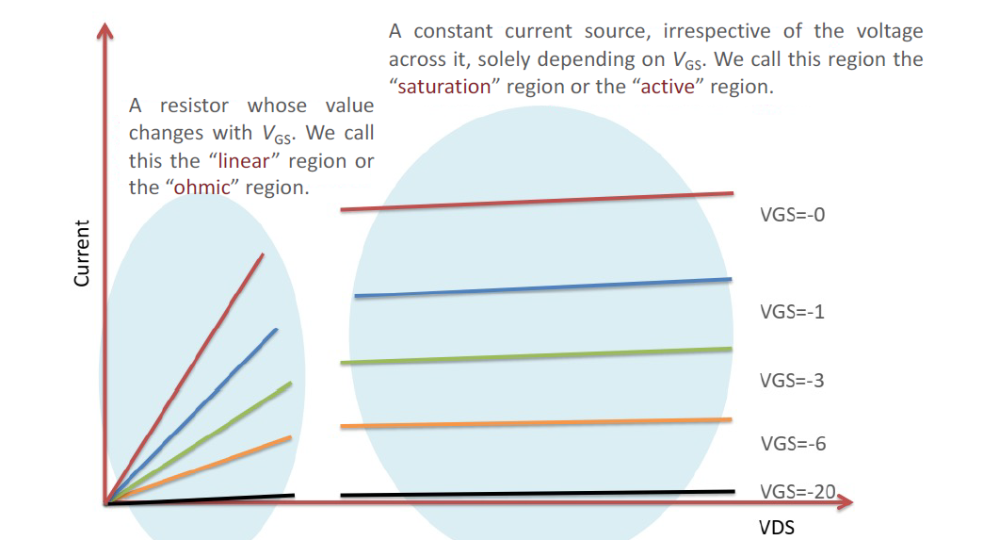
三个区域
Cut-off region: When VGS < VT, no channel is induced and the MOSFET is in the cut-off region. No
current flows.
Triode region: When VGS ≥ VT, a channel is induced and current starts flowing if VDS > 0. A
MOSFET is in the triode region as long as VDS < VGS – VT. A MOSFET in the triode region behaves
like a ‘tunable resistor’ whose resistance can be modified by changing VGS.
Saturation region: When VGS ≥ VT and VDS ≥ VGS – VT, the channel is in saturation and the drain
current is almost constant. There is very little or no increase in the drain current when VDS is
further increased.
Triode region 的公式
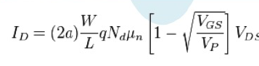
Saturation region的公式
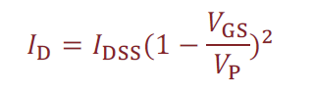
Idss is the maximum drain current for a JFET that occurs at VGS = 0. 𝐼!"" is named after the “drain-to-source current with a short-circuit connection from gate to source”;
VP is the pinch-off voltage
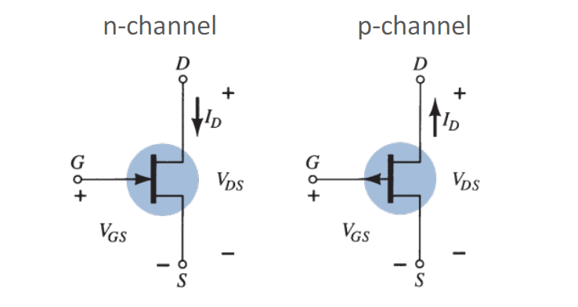

Metal-Oxide-Semiconductor Field Effect Transistors (MOSFETs)

MOS管的基础知识
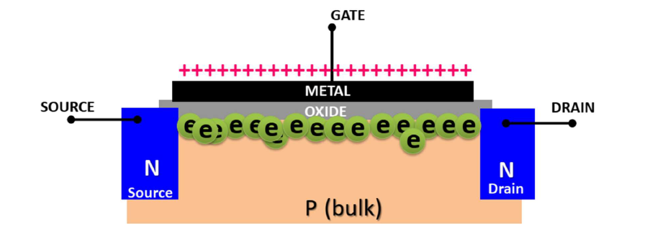
原理，Gate施加电压，使电子被吸引上去形成一个通路inversion region
形成这个通路的最小电压为阈值电压VT (the threshold voltage)
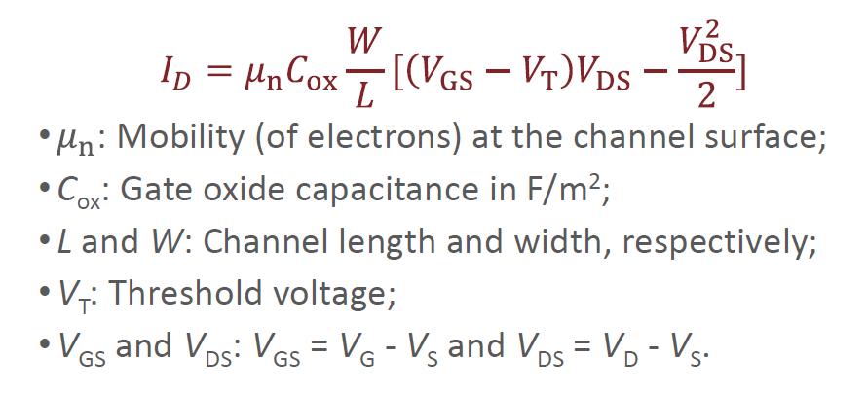
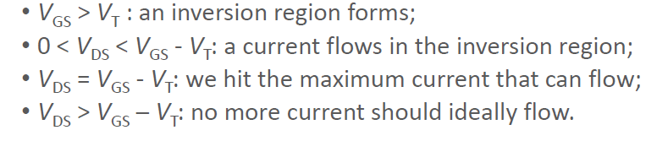
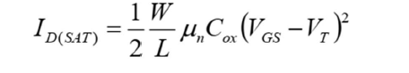
考虑沟道长度调制效应
L会因为Vds的增大而减小，那么Id仍然会缓慢的增加
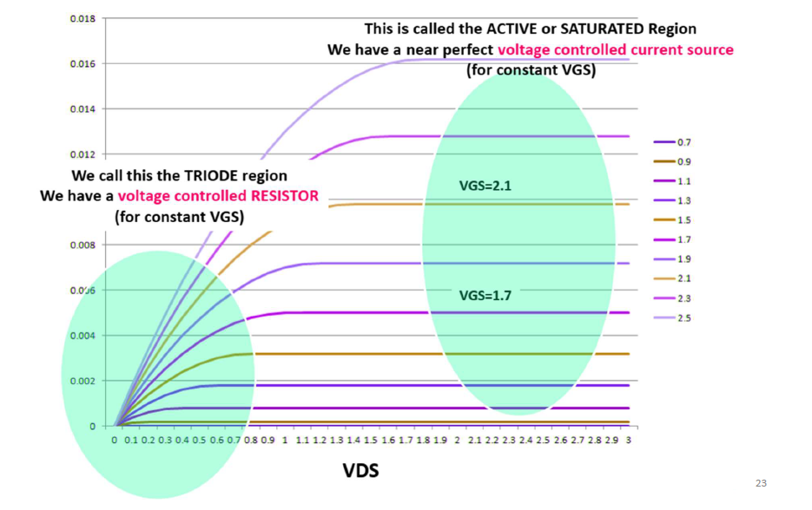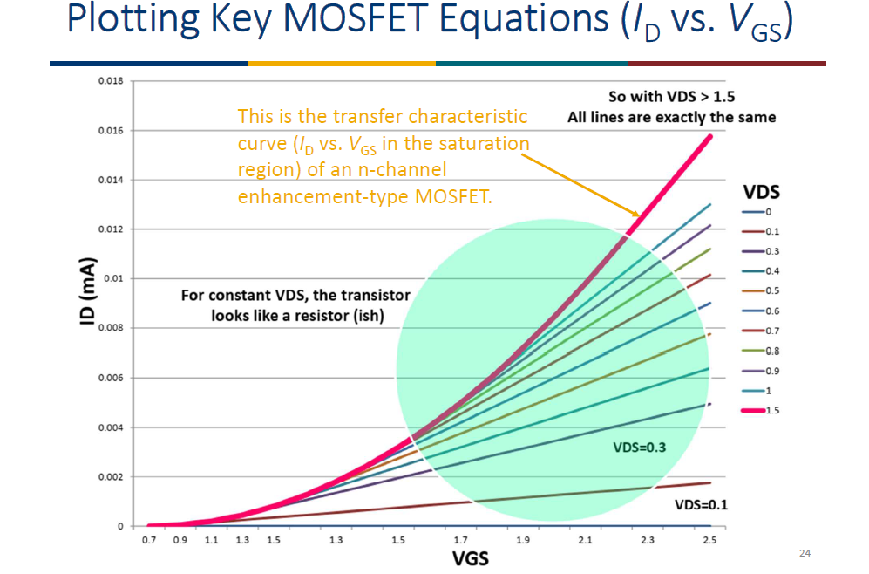
特性曲线如上

寄生元件Parasitic Components in MOSFETs
就是因为Gate极和下面隔着一个氧化物绝缘体，那么这个时候上面下面都是带电板，那么这就等同于一个电容器，所以在G和D，G和S间实际上都会有一个电容的存在
对于高频的充放电会有较大影响
CGS is the biggest in size but CGD has the biggest impact

MOS管的分类
NMOS & PMOS
对于增强型来讲enhancement-type
N型n道沟，Vgs>0时导通，P道沟Vgs<0时导通

例题增强型和耗尽型的分类

The two types of MOSFETs are depletion-type MOSFETs and enhancement-type MOSFETs.
In depletion-type MOSFETs, when there is no voltage on the gate, a conduction channel still exists
between the source and the drain, and the transistor is in the “ON” state. When a gate voltage is
applied, depending on its polarity, it can either reduce the number of charge carriers in the
channel (the MOSFET is said to operate in the depletion mode which is also its most common
mode of operation) or increase the number of charge carriers in the channel (the enhancement
mode of operation). In the depletion mode of operation, the channel conductivity decreases
while in the enhancement mode of operation, the channel conductivity increases.
For enhancement-type MOSFETs, when there is no voltage on the gate, there is no conduction
channel. Thus, the transistor is in the “OFF” state. A channel is only created by the application of
a voltage to the gate. The greater (the absolute value of) the gate voltage is, the better the device
conducts.
增强型的符号
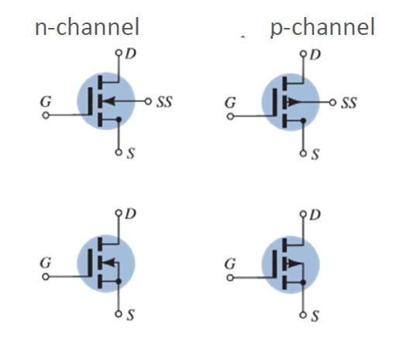
耗尽型的符号
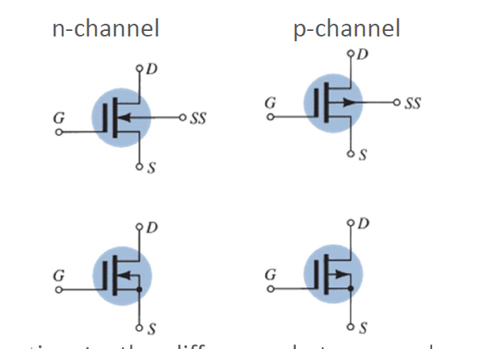

CMOS complementary MOSFET互补的MOS

MOSFET的应用

Resistor
提供一个小的直流电阻small DC resistance
we can make pretty accurate low-value resistors
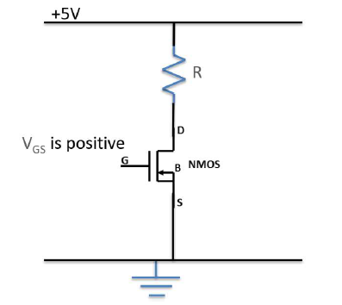
推导应用线性区公式
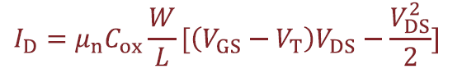
Vds平方极小可以被忽略
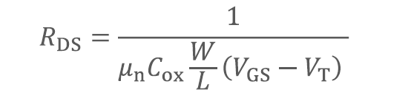

优点：
1、It is voltage controlled, so we can change it;
• It can be precise, we can get a resistance exactly TWICE of another, etc;
• It is smaller than the area we would need to make a resistor in silicon.

对于大的值时要带入饱和区公式，经过推导得到Rds将与Vds有关，也就是非线性变化
所以根据Vgs可以分为三个阶段的电阻，对我们有用的一般是第二个
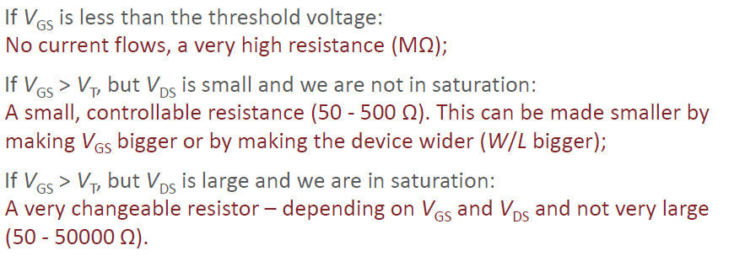

Switch
对PMOS来说
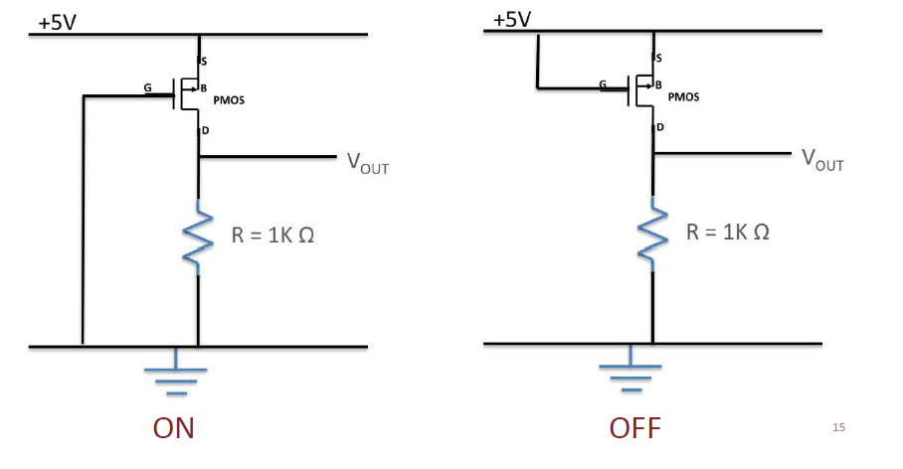
就是通过改变Vgs的值来使阻值变化
对NMOS来说S极要接地

逻辑门CMOS Logic
通过同时使用NMOS和PMOS来导致Vout随输入信号而变化
原理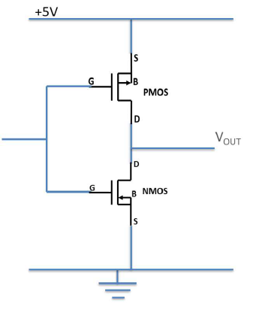
对这样的电路接5V和接地分别使Vout=0或5，也就是成为了非门
其他的几个逻辑电路
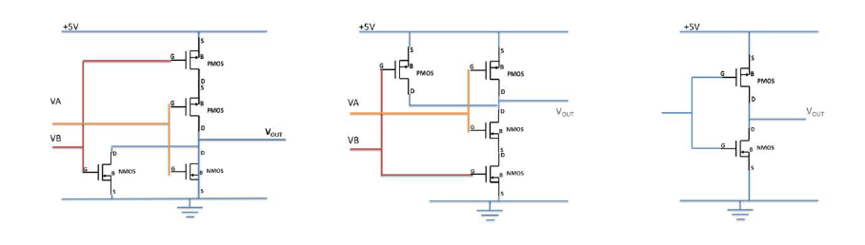
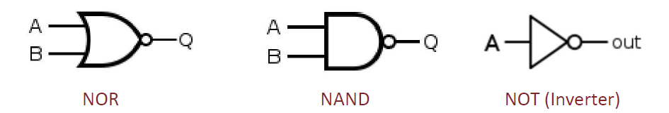

CMOS效率和执行速度都不错，但也有一些缺点
考虑我们上面说的寄生元件，因为存在电容，也就是说会有电能消耗在这上面
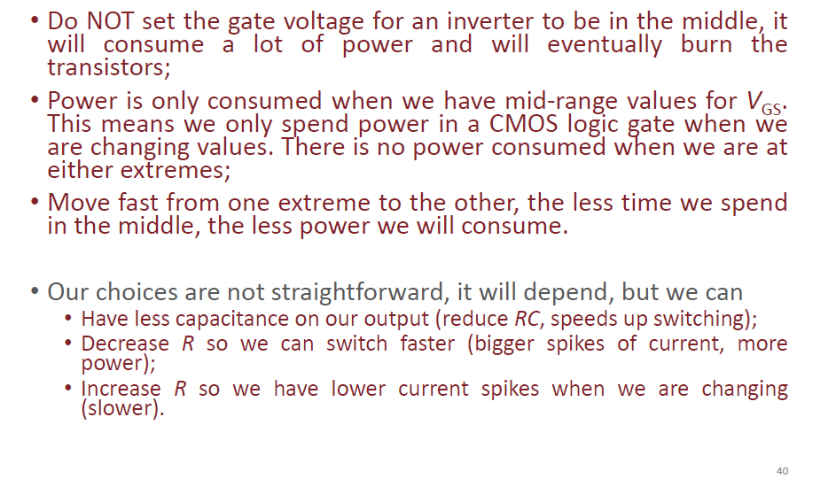

Signal Gates or Switches
Make/Break Switches
相关题目要记得考虑这个公式
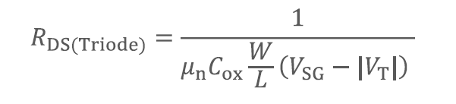

Models

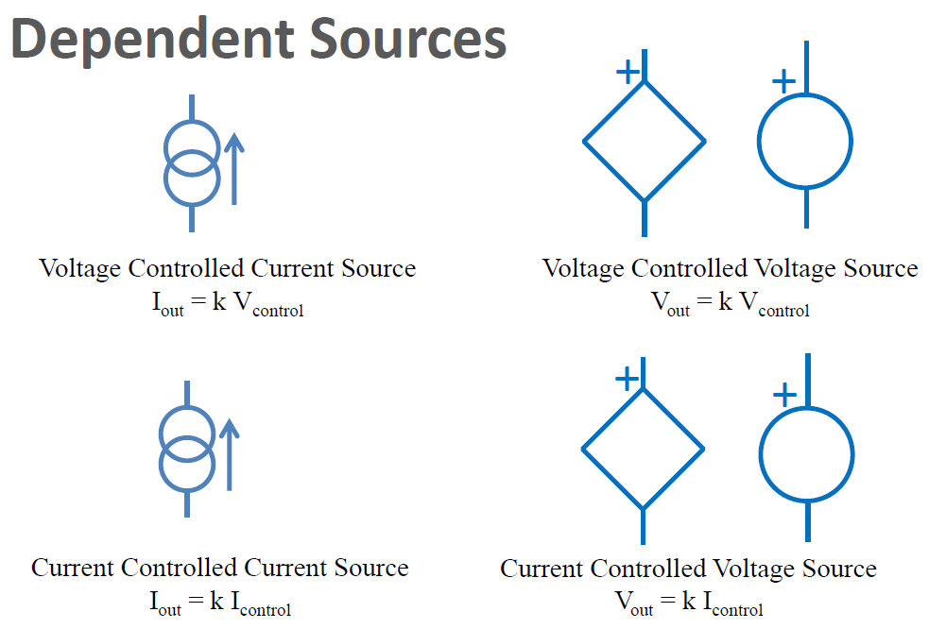

Biasing and Small Signal Behaviour

Small signal
Small Signals are small changes that are so small that they stay is a region on the curve where everything looks like a straight line (we call straight-line regions LINEAR)
Small Signals are always considered to be time-varying signals with zero average values – often picked up from the sensors and need to be amplified.

FET
线性区
恒流区
MOSFET的公式（沟道长度调制效应）
在线性区
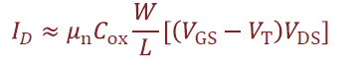
在饱和区，此时与Vds无关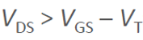
MOSFET做电阻
考虑沟道长度调制效应
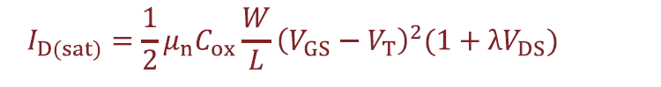
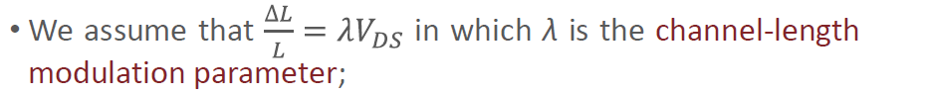

小信号晶体管
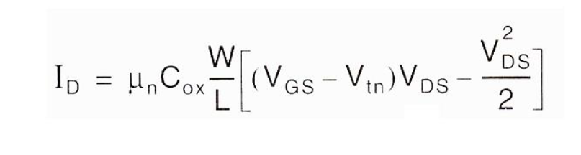

FET Amplifiers

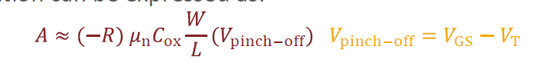
If in saturation, the gain is determined by the VGS voltage only, and the value of resistance R.

这种硬件对于大信号和小信号有不同的特性曲线，我们做题时只关注小信号
为了研究这类题目我们引入一系列双端模型，
• H-parameter *
• Hybrid-π *
也就是说，我们只知道输入输出而不了解其中具体的过程

